

Software Metrics

Prof. Yordanka Budinova

Assignment 1

Due date: 23rd November 2021

**Prepared by**

|  |  |
| --- | --- |
| Name: | Ario Anindito |
| Student ID: | 2016082 |
| Programme: | Bachelor of Science  (Software Engineering) |

**Software Metrics Assignment 1 – Report One**

The purpose of this report is to outline the calculation results for the following metrics: LOC, PLOC, and Comments. I used Radon as a tool to accomplish.

Radon is a Python tool which computes various code metrics. Supported metrics are:

* Raw metrics: SLOC, comment lines, blank lines, &c.
* Cyclomatic Complexity (i.e. McCabe’s Complexity)
* Halstead metrics (all of them)
* The Maintainability Index (a Visual Studio metric)

Raw command in Radon analyzes the given Python modules in order to compute raw metrics. These include:

* LOC: the total number of lines of code
* LLOC: the number of logical lines of code
* SLOC: the number of source lines of code - not necessarily corresponding to the LLOC [Wikipedia]
* comments: the number of Python comment lines (i.e. only single-line comments #)
* multi: the number of lines representing multi-line strings
* blank: the number of blank lines (or whitespace-only ones)

Finally, I used pylint to get the review/score in term of bug and quality check for the code, then made an improvement afterwards.

I put all the file project inside my repository <https://github.com/arioanindito>

Code before improvement

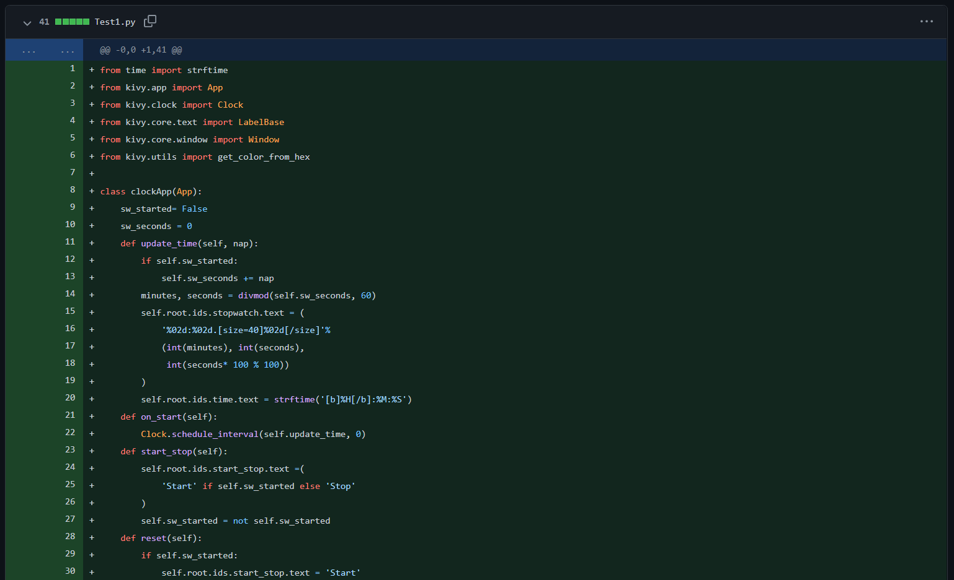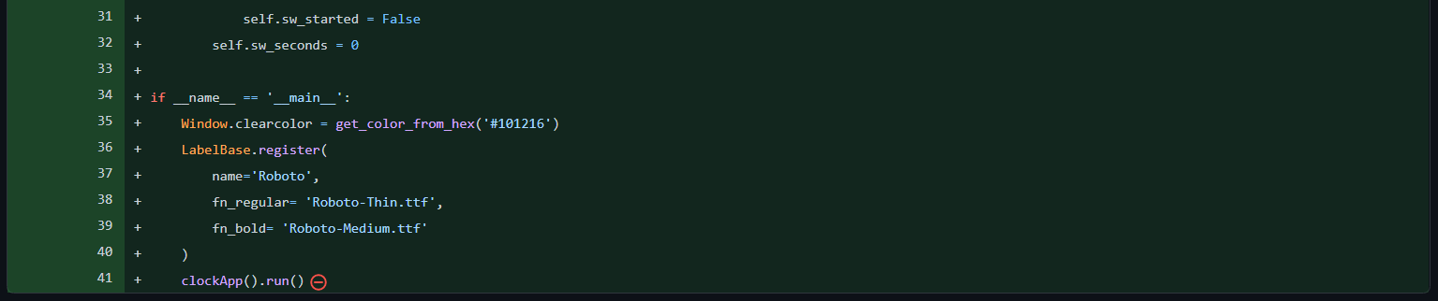

The code is all about a simple clock app with python using the kivy module in python.

The result for metrics and pylint results are followed (Respectively):

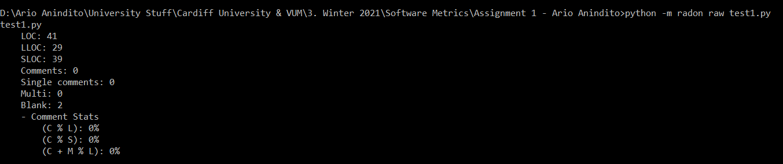

The metrics result (before improvement)

LOC: 41

LLOC: 29

Comments: 0

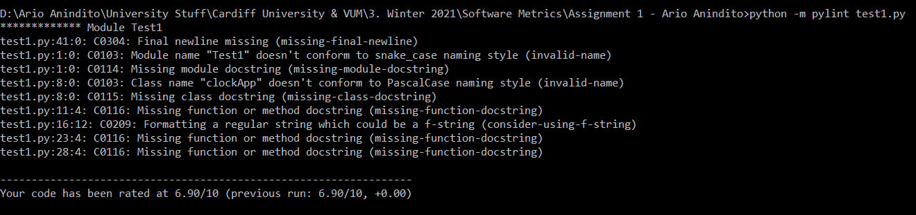

The pylint result (before improvement)

Code has been rated at (6.90/10.00)

I made an improvement a couple times, and these are the following result:

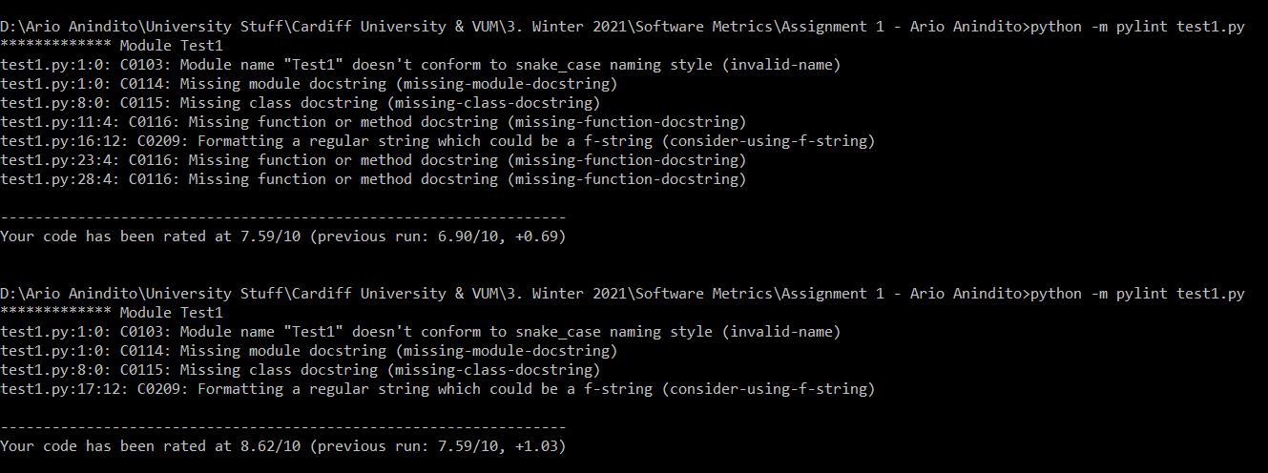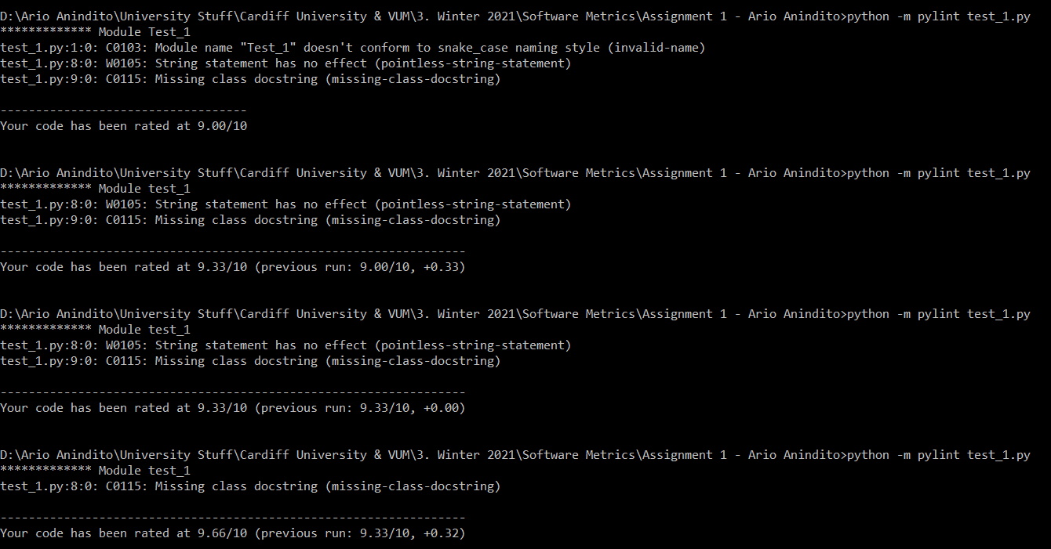

At the end, the result for pylint become 10.00/10.00, with the radon result are followed:

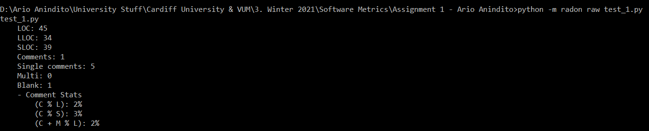

Moreover, if we compare side by side the code before and after improvement we got the following result:

<https://github.com/arioanindito/swm2021/commit/4177faa45a3ec1bcd1e468c79250ab80b792c8dd>

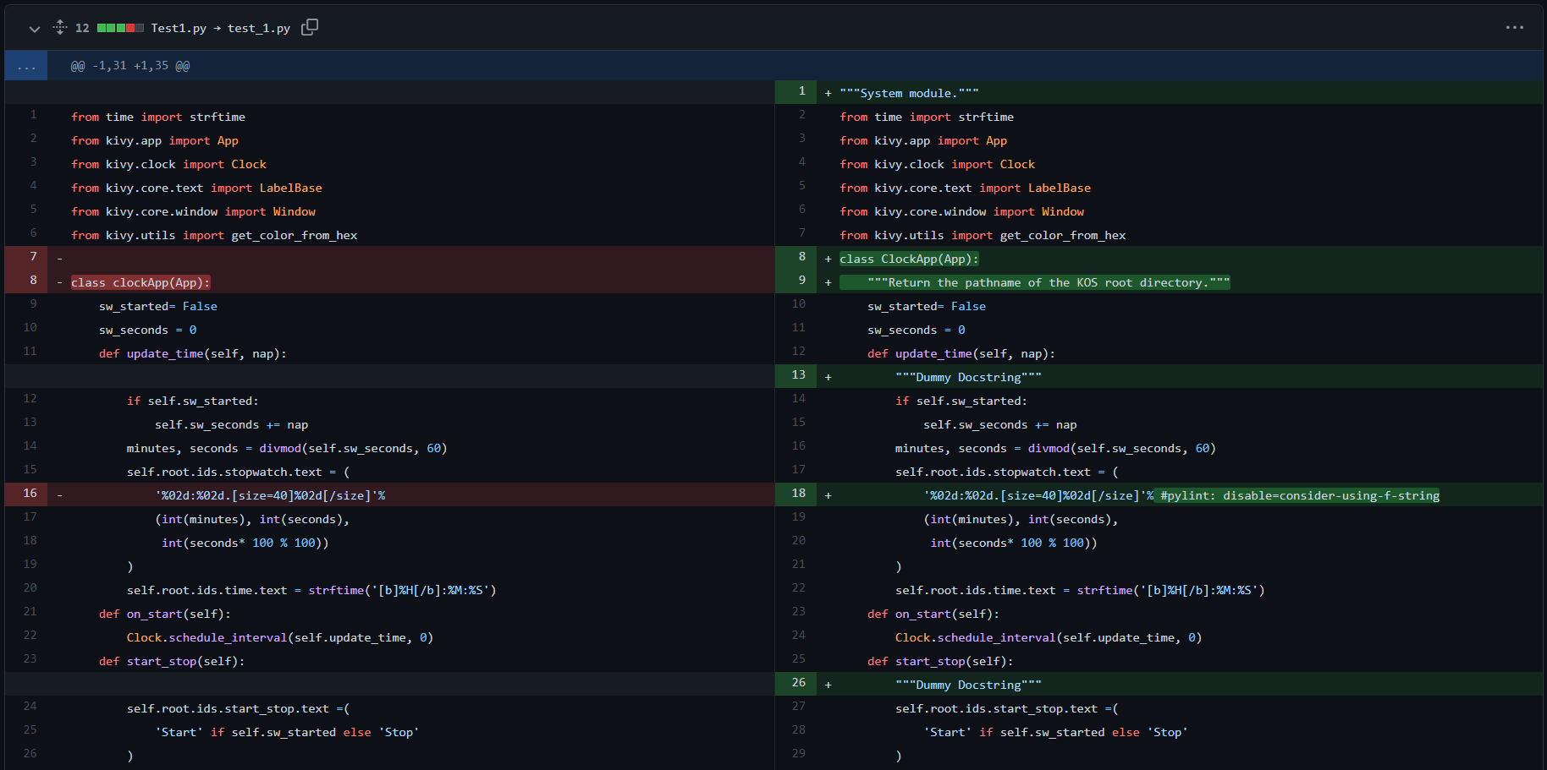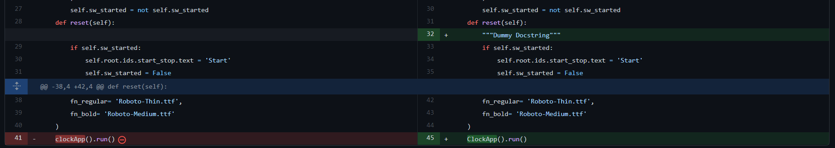

**Software Metrics Assignment 1 – Report Two**

The purpose of this report is to outline the calculation results for the following metrics: LOC, PLOC, and Comments. I used Loc Metrics as a tool to accomplish.

The overall user interface of Loc Metrics are followed:

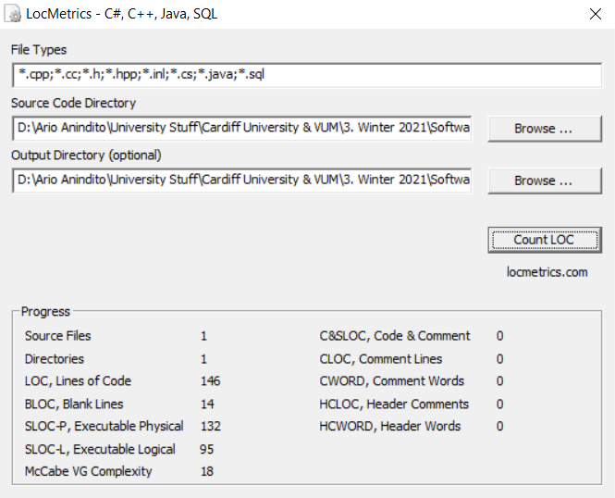

After choosing the directory that I put the source code in, I just need to click “Count LOC” button to begin measurement. Loc Metrics created the results as a report files to the directory as shown below.

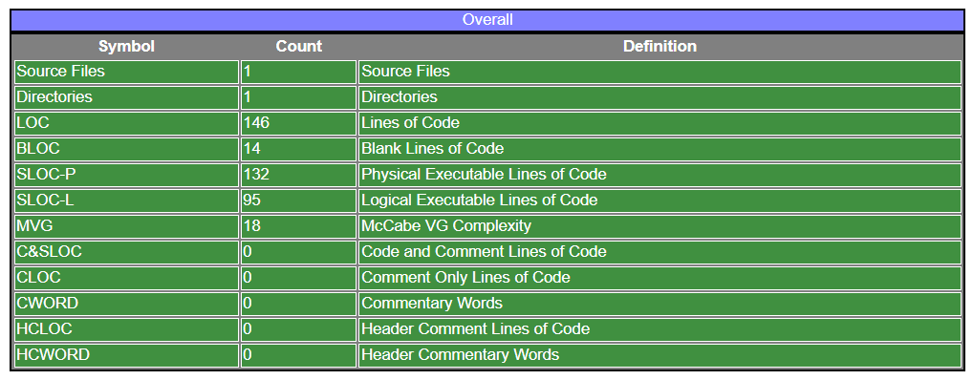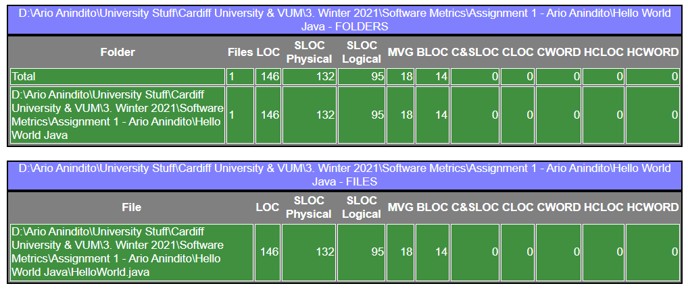

The program also generate analyzed reports using pie charts and tables as shown below.

